Table of Contents
HTML & CSS 2
Basic syntax 2
HTML Page Structure 2
HTML Layout 2
Reference 2
XML & XML Schema 3
How to Validate a XML in Eclipse? 3
XML Schema 3
XPath & XSL 4
XML Parsing in Java 4
Using DOM Parser 5
Using SAX Parser 5
Using StAX Parser 5
Bootstrap 6
Using Bootstrap 6
Why Use Bootstrap? 6
How do we use Bootstrap? 6
JQuery 7
What is jQuery? 7
How do we use it? 7
jQuery Syntax 7
jQuery Selector 8
More Examples of jQuery Selector 8
jQuery Event Methods 8
Commonly Used jQuery Event Methods 9
jQuery Effects – Hide & Show 9
jQuery Fading Methods 9
jQuery Effects – Sliding, Animation, Stop Animations, Callback 9
jQuery Method Chaining 9
jQuery – AJAX 9

HTML & CSS

Basic syntax
- The DOCTYPE declaration defines the document type to be HTML. The <!DOCTYPE> declaration helps the browser to display a web page correctly.
- The text between <html> and </html> describes an HTML document
- The text between <head> and </head> provides information about the document
- The text between <title> and </title> provides a title for the document
- The text between <body> and </body> describes the visible page content
- The text between <h1> and </h1> describes a heading
- The text between <p> and </p> describes paragraph

HTML Page Structure
<html>
<head>
<title>Page title</title>
</head>
<body>
<h1>This is a heading</h1>
<p>This is a paragraph.</p>
<p>This is another paragraph.</p>
</body>
</html>

HTML Layout
The <div> element is often used as a layout tool, because it can easily be positioned with CSS.
Example – staticpage\HtmlLayout.html
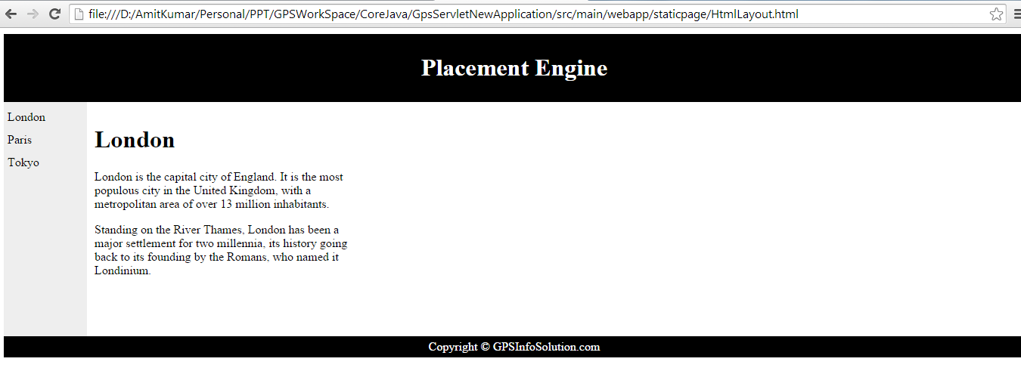
3 ways to Insert CSS – http://www.w3schools.com/css/css_howto.asp

Reference
HTML - http://www.w3schools.com/html/
CSS - http://www.w3schools.com/css/
CSS Syntax - http://www.w3schools.com/css/css_syntax.asp

XML & XML Schema
XML stands for EXtensible Markup Language
XML was designed to describe data, For ex-
<?xml version="1.0" encoding="UTF-8"?>
<note>
<to> Tove</to>
<from>Jani</from>
<heading>Reminder</heading>
<body>Don't forget me this weekend!</body>
</note>

How to Validate a XML in Eclipse?

XML Schema
An XML Schema describes the structure of an XML document. An XML Schema:
- defines elements that can appear in a document
- defines attributes that can appear in a document
- defines which elements are child elements
- defines the order of child elements
- defines the number of child elements
- defines whether an element is empty or can include text
- defines data types for elements and attributes
- defines default and fixed values for elements and attributes
For EX-
<?xml version="1.0"?>
<xs:schema xmlns:xs=http://www.w3.org/2001/XMLSchema targetNamespace=”http://www.w3schools.com" xmlns="http://www.w3schools.com">
<xs:element name="note">
<xs:complexType>
<xs:sequence>
<xs:element name="to" type="xs:string"/>
<xs:element name="from" type="xs:string"/>
<xs:element name="heading" type="xs:string"/>
<xs:element name="body" type="xs:string"/>
</xs:sequence>
</xs:complexType>
</xs:element>
</xs:schema>

<?xml version="1.0"?>
<note xmlns=http://www.w3schools.com
xmlns:xsi="http://www.w3.org/2001/XMLSchema-instance"
xsi:schemaLocation="note.xsd">
<to>Tove</to>
<from>Jani</from>
<heading>Reminder</heading>
<body>Don't forget me this weekend!</body>
</note>

XPath & XSL
XPath is a query language used to traverse through an XML document. It is used commonly to search particular elements or attribute with matching patterns.
XPath uses a path expression to select node or list of nodes from an xml document. Following is the list of useful paths and expression to select any node/ list of nodes from an xml document –
Expression | Description
node-name | Select all nodes with the given name "nodename"
/ | Selection starts from the root node
// | Selection starts from the current node that match the selection
. | Selects the current node
.. | Selects the parent of the current node
@ | Selects attributes
student | Example: Selects all nodes with the name "student"
class/student | Example: Selects all student elements that are children of class
//student | Selects all student elements no matter where they are in the document

Why need XSL?
XSL which stands for EXtensibleStylesheet Langauge. It is similar to XML as CSS is to HTML.
In case of HTML document, tags are predefined such as table, div, span and browser knows how to add style to them and display them using CSS styles. But in case of XML document, tags are not predefined. In order to understand and style an XML document, World Wide Web Consortium (W3C) developed XSL which can act as XML based Stylesheet Language. An XSL document specifies how a browser should render an XML document.
Example – Core Java: com.src.java.resource: Students.xml & Students.xsl

XML Parsing in Java
Every emerging technology incorporates XML. Java supports XML by providing JAXP and it has multiple ways for xml processing and they are SAX, DOM, TrAX, StAX and JAXB.

Using DOM Parser
The DOM Parser loads the complete XML content into a Tree structure into Memory. We iterate through the Node and NodeList to get the content of the XML. DOM Parser is slow and consumes a lot memory if it loads a XML document which contains a lot of data. When working with small documents are fine with this kind of DOM processing but when you have a long document and then we will have performance issues.
Example – CoreJava: com.src.java.resource: Employee.xml
CoreJava: com.src.xml.parsing: Employee.java, DOMParserDemo.java

Using SAX Parser
- SAX Parser is different from the DOM Parser where SAX parser doesn’t load the complete XML into the memory, instead it parses the XML line by line triggering different events as and when it encounters different elements like: opening tag, closing tag, character data, and comments and so on. This is the reason why SAX Parser is called an event based parser. SAX Parser is faster and uses less memory than DOM parser. SAX is a uni-directional, read only API and follows push model for reading.

Using StAX Parser
StAX is a streaming pull-parsing java API for reading and writing XMLs and it is an alternate to SAX, DOM and TrAX. StAX API is a set of interfaces providing a framework for bi-directional parser. It provides two sets of APIs, cursor and iterator based.

Bootstrap

Using Bootstrap
- Bootstrap is a free front-end framework for faster and easier web development
- Bootstrap includes HTML and CSS based design templates for typography, forms, buttons, tables, navigation, modals, image carousels and many other, as well as optional JavaScript plugins
Example – staticpage\BootstrapExample.html
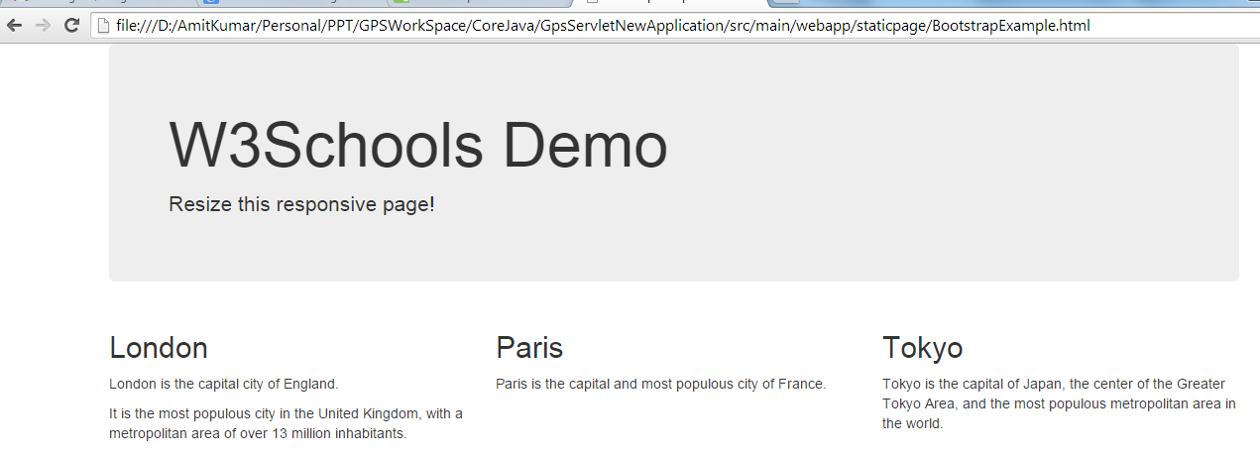

Why Use Bootstrap?
Advantages of Bootstrap:
- Easy to use: Anybody with just basic knowledge of HTML and CSS can start using Bootstrap
- Responsive features: Bootstrap's responsive CSS adjusts to phones, tablets, and desktops
- Mobile-first approach: In Bootstrap 3, mobile-first styles are part of the core framework
- Browser compatibility: Bootstrap is compatible with all modern browsers (Chrome, Firefox, Internet Explorer, Safari, and Opera)

How do we use Bootstrap?
- Download Bootstrap from http://getbootstrap.com/
- Extract bootstrap-3.3.1-dist.zip & copy CSS, Font & JS inside src\main\webapp
Example – BootStrapExample.html, BootStrapFormExample.html
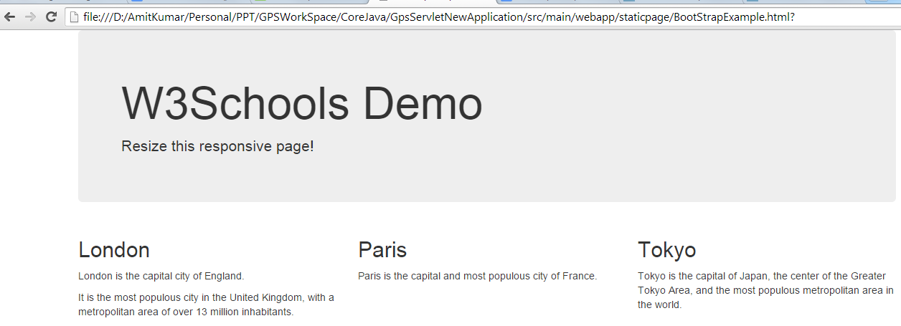
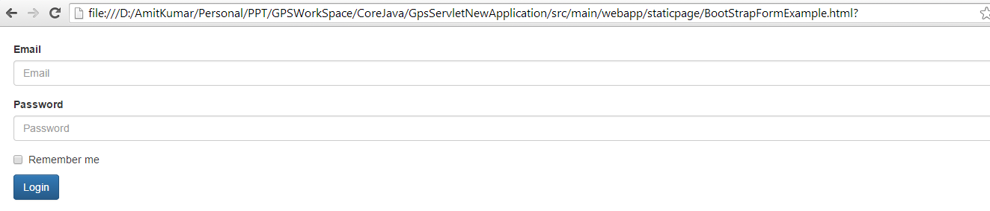
Reference - http://www.tutorialrepublic.com/twitter-bootstrap-examples.php
http://twitter.github.com/bootstrap/
http://bootswatch.com/
http://fortawesome.github.com/Font-Awesome/

JQuery

What is jQuery?
JQuery is a fast, small, and feature-rich JavaScript library. It makes things like HTML document traversal and manipulation, event handling, animation, and Ajax much simpler with an easy-to-use API that works across a multitude of browsers.
The purpose of jQuery is to make it much easier to use JavaScript on your website.

How do we use it?
Download jQuery js file from - http://jquery.com/download/ & put it into src\main\webapp\js folder
The jQuery library is a single JavaScript file, and you reference it with the HTML <script> tag (notice that the <script> tag should be inside the <head> section):
<head>
<script src="jquery-1.11.1.min.js"></script>
</head>
With jQuery you select (query) HTML elements and perform "actions" on them.

jQuery Syntax
The jQuery syntax is tailor made for selecting HTML elements and performing some action on the element(s).
Basic syntax is: $(selector).action()
- A $ sign to define/access jQuery
- A (selector) to "query (or find)" HTML elements
- A jQuery action() to be performed on the element(s)
Examples:
- $(this).hide() - hides the current element.
- $("p").hide() - hides all <p> elements.
- $(".test").hide() - hides all elements with class="test".
- $("#test").hide() - hides the element with id="test".

jQuery Selector
jQuery selectors are one of the most important parts of the jQuery library. jQuery selectors allow you to select and manipulate HTML element(s).
jQuery selectors are used to "find" (or select) HTML elements based on their id, classes, types, attributes, values of attributes and much more.
All selectors in jQuery start with the dollar sign and parentheses: $().

The Element Selector
The jQuery element selector selects elements based on the element name.
You can select all <p> elements on a page like this: $("p")
Example- When a user clicks on a button, all <p> elements will be hidden.
hideParagraph.html

The #id Selector
The jQuery #id selector uses the id attribute of an HTML tag to find the specific element.
An id should be unique within a page, so you should use the #id selector when you want to find a single, unique element.
To find an element with a specific id, write a hash character, followed by the id of the HTML element: $("#test")
Example- When a user clicks on a button, the element with id="test" will be hidden.
idSelectorExample.html

The .class Selector
To find elements with a specific class, write a period character, followed by the name of the class: $(".test")
Example- When a user clicks on a button, the elements with class="test" will be hidden.
classSelectorExample.html

More Examples of jQuery Selector
http://www.w3schools.com/jquery/jquery_selectors.asp

jQuery Event Methods
All the different visitor's actions that a web page can respond to are called events.
An event represents the precise moment when something happens.
Here are some common DOM events:
Mouse Events | Keyboard Events | Form Events | Document/Window Events
Click | keypress | Submit | load
Dblclick | keydown | Change | resize
Mouseenter | Keyup | Focus | scroll
Mouseleave |  | Blur | unload

Commonly Used jQuery Event Methods
In jQuery, most DOM events have an equivalent jQuery method.
To assign a click event to all paragraphs on a page, you can do this:
$("p").click();
The next step is to define what should happen when the event fires. You must pass a function to the event:
$("p").click(function(){
// action goes here!!
});
http://www.w3schools.com/jquery/jquery_events.asp

jQuery Effects – Hide & Show
http://www.w3schools.com/jquery/jquery_hide_show.asp

jQuery Fading Methods
http://www.w3schools.com/jquery/jquery_fade.asp

jQuery Effects – Sliding, Animation, Stop Animations, Callback
http://www.w3schools.com/jquery/jquery_slide.asp
http://www.w3schools.com/jquery/jquery_animate.asp
http://www.w3schools.com/jquery/jquery_stop.asp
http://www.w3schools.com/jquery/jquery_callback.asp

jQuery Method Chaining
http://www.w3schools.com/jquery/jquery_chaining.asp

jQuery – AJAX
AJAX (Asynchronous JavaScript and XML) is the art of exchanging data with a server, and updating parts of a web page - without reloading the whole page.
In short; AJAX is about loading data in the background and display it on the webpage, without reloading the whole page.
jQuery provides several methods for AJAX functionality.
With the jQuery AJAX methods, you can request text, HTML, XML, or JSON from a remote server using both HTTP Get and HTTP Post - And you can load the external data directly into the selected HTML elements of your web page!

jQuery load() Method
The jQuery load() method is a simple, but powerful AJAX method.
The load() method loads data from a server and puts the returned data into the selected element.
$(selector).load(URL,data,callback);
The required URL parameter specifies the URL you wish to load.
The optional data parameter specifies a set of query string key/value pairs to send along with the request.
The optional callback parameter is the name of a function to be executed after the load() method is completed.
http://www.w3schools.com/jquery/tryit.asp?filename=tryjquery_ajax_load
The optional callback parameter specifies a callback function to run when the load() method is completed. The callback function can have different parameters:
- responseTxt - contains the resulting content if the call succeeds
- statusTxt - contains the status of the call
- xhr - contains the XMLHttpRequest object
http://www.w3schools.com/jquery/tryit.asp?filename=tryjquery_ajax_load_callback

jQuery $.get() Method
http://www.w3schools.com/jquery/tryit.asp?filename=tryjquery_ajax_get
jQuery $.post() Method
http://www.w3schools.com/jquery/tryit.asp?filename=tryjquery_ajax_post
Reference URL- https://jqueryui.com/draggable/

